Practical No:04

**Aim:** Documentations:

1. Finding info Documentation: From command line: Bring up the info page for the grep command. Bring up the usage section.

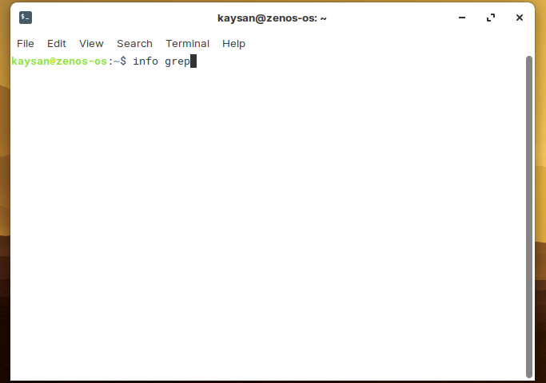

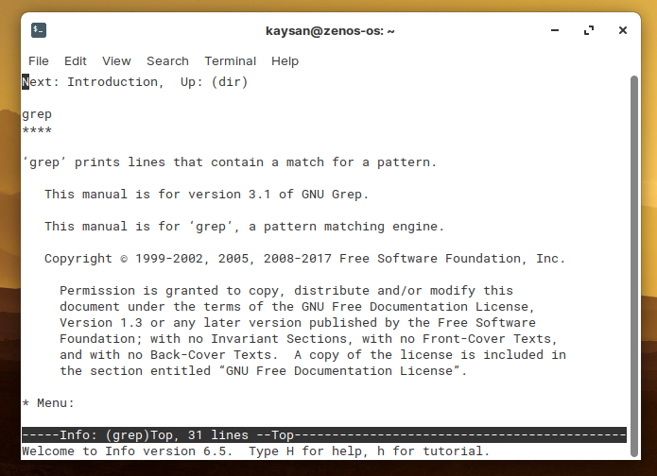

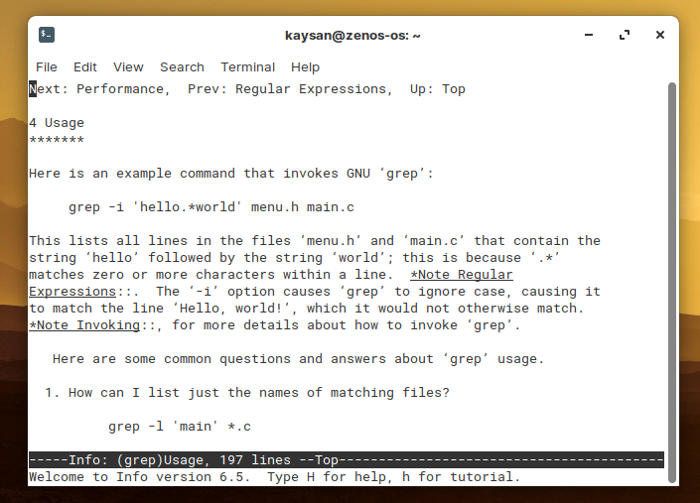

b) Finding man pages from cmd: Bring up the man page for the ‘ls’ Command.

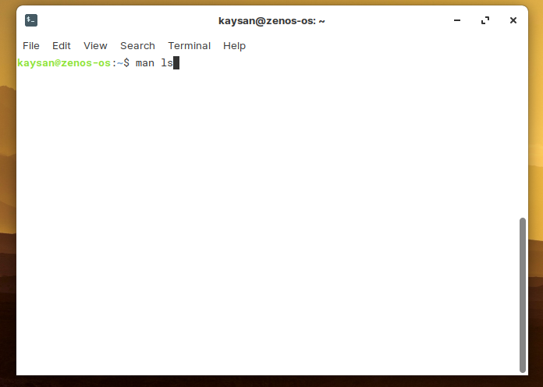

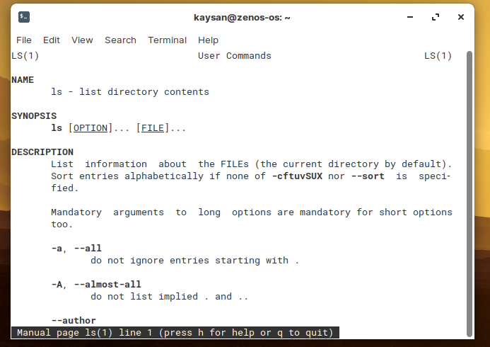

c) Finding man pages by topic: What man pages are available that document file compression?

**Commands:**

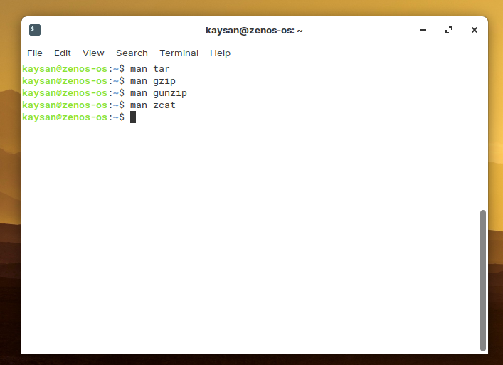

**Command: man tar**

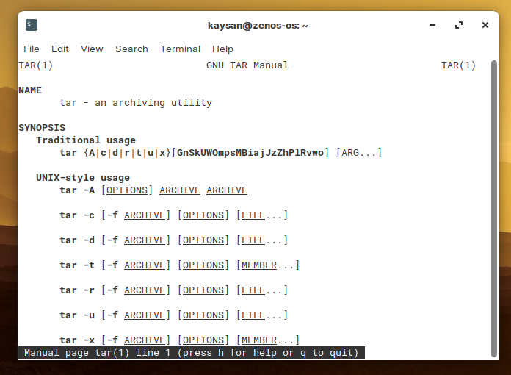

**Command: man gzip, man gunzip, man zcat**

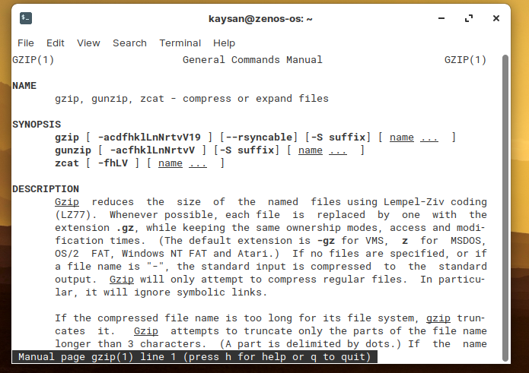

d) Finding man pages by Section From the command line, bring up the man page for the printf library function. Which manual page section are library functions found?

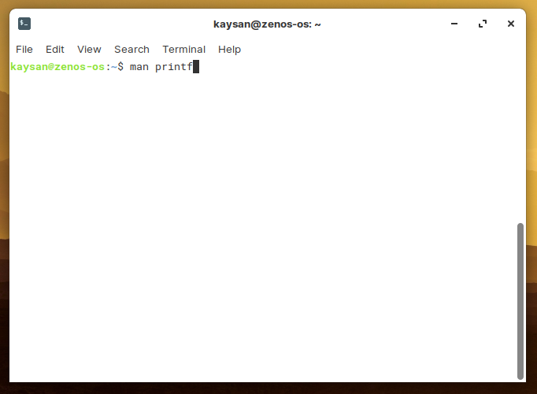

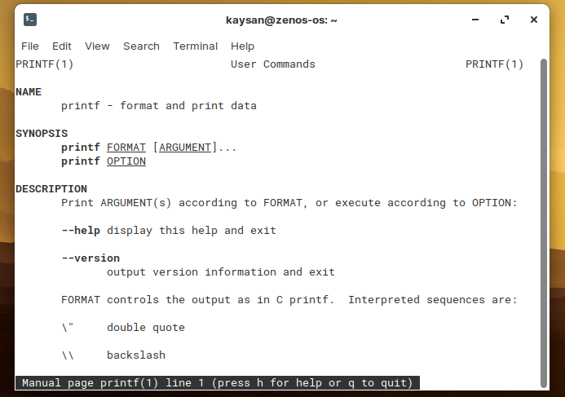

e) Command-Line Help List the available options for the mkdir command. How can you do  
this?

Use mkdir –help command

